**Business Intelligence**

**Case St****udy**

**Case Study: Inventory Optimization in the Supply Chain**

**TABLE OF CONTENT**

**Introduction** **3**

**Executive Summary** **3**

**Business Problem****4**

**Optimization Solution****5**

**Benefits****8**

**Challenges****8**

**Conclusion & Recommendations** **11**

**References** **1****2**

**Introduction**

This report focuses on optimizing inventory management using machine learning techniques. It addresses the challenge of efficiently managing inventory in the supply chain of a rapidly expanding e-commerce company, VDOMES.

The modern supply chain landscape is fraught with challenges, and one of the recurring issues faced by businesses is the efficient management of inventory. In this report, we aim to address the pressing problem of inventory optimization within the supply chain department of this company. Our objective is to develop an optimization strategy that leverages machine learning techniques to predict product sales and profit ensuring a streamlined and responsive inventory management process.

**Executive Summary**

This case study delves into the imperative task of optimizing inventory management for VDOMES, a rapidly expanding e-commerce giant, through the integration of machine learning techniques. The report underscores the prevalent challenges in the existing inventory management processes, notably the identification of high-demand products, managing slow-moving items, and anticipating potential obsolescence. Traditional methods are found lacking in their ability to provide real-time insights and predictive capabilities crucial for effective decision-making in the dynamic supply chain landscape.

The proposed solution revolves around the implementation of machine learning techniques, specifically predictive analytics, to predict product backorders. By harnessing historical data, this strategy enables accurate demand forecasting, differentiating between products with high demand and those at risk of becoming obsolete. A practical demonstration utilizing a subset of inventory data showcases the model's proficiency in predicting backorders, facilitating proactive management and averting stock-out scenarios. The associated benefits encompass enhanced sales and inventory management, efficient resource allocation, cost reduction, and improved customer satisfaction. Despite these advantages, the report acknowledges challenges related to data quality and implementation complexity, emphasizing the importance of careful planning. The overall recommendation is a phased implementation approach, ensuring thorough testing and continuous monitoring, positioning machine learning as a potent solution for overcoming supply chain challenges and fostering sustained growth for VDOMES.

**Business Problem**

VDOMES, an e-commerce platform, has established a global presence by facilitating the sale and distribution of various goods through its online platform and shipping infrastructure. Despite a successful year in terms of overall business, a detailed analysis has revealed a critical issue within the system. The product categories that contribute significantly to the platform's profitability are experiencing challenges related to delayed deliveries, resulting in dissatisfied customers, negative impacts on the brand's image across social media platforms, increased return rates due to late shipments, and financial losses incurred from discounts and coupons offered to compensate for delivery delays.

In response to these challenges, the management has made a strategic decision for the upcoming year. The focus will be narrowed down to the most popular and profitable product categories, accompanied by a proactive initiative to minimize late deliveries and enhance overall profitability compared to the previous year. The management aims to accurately predict sales for the next year to facilitate improved inventory planning, efficient resource allocation, elimination of low-performing Stock Keeping Units (SKUs), and optimal utilization of resources from inventory procurement to warehouse storage.

To address the existing issues and achieve the outlined objectives, the management is seeking a solution that involves determining the ideal product categories to retain and the appropriate allocation of space for each category. This approach is envisioned to not only reduce delivery delays but also mitigate the risk of excess unsold stock, ultimately optimizing the utilization of resources throughout the supply chain.

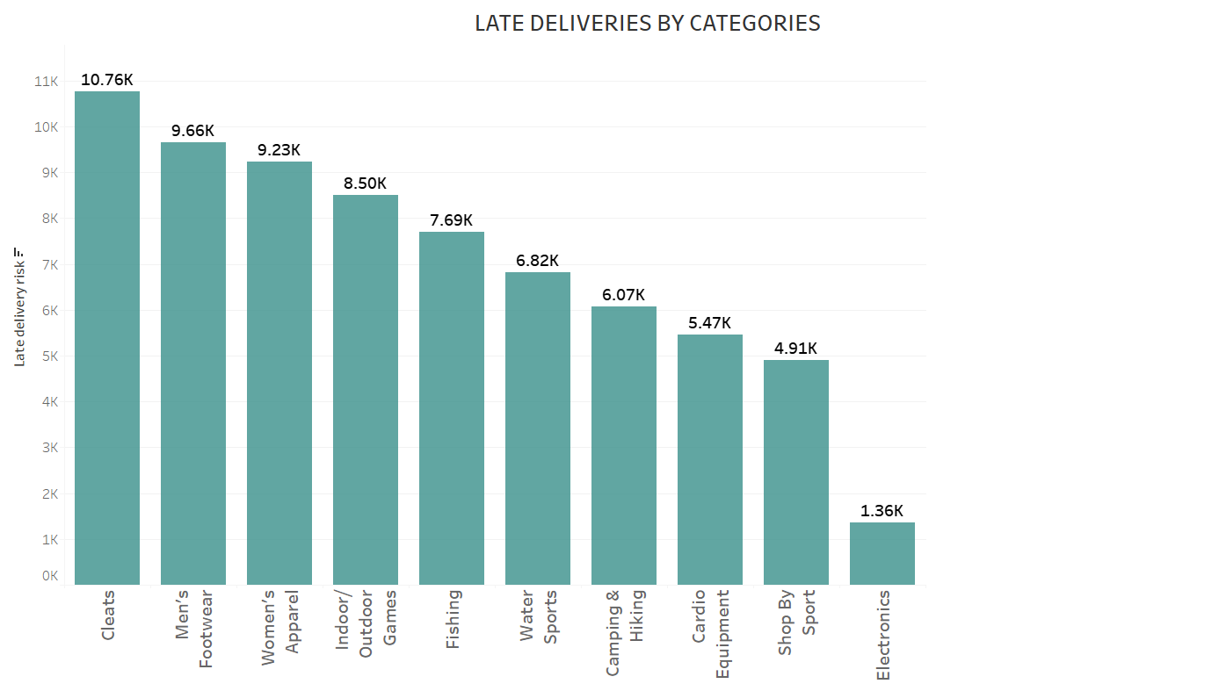

***Figure 1***. The above figures show the number of late deliveries by category in the last year.

**Optimization Solution**

The solution being proposed to the management is that we focus on the highest-selling categories on our website and stock them sufficiently. So that we can reduce the number of late deliveries by having stock at hand leading to a reduction in revenue loss, due to missed opportunities as well as refunds due to late deliveries. To action this solution, we will remove the low-selling categories as these tend to occupy space in the warehouse for longer than anticipated time and also leave unsold inventory leading to higher costs as well as less space to stock the high-selling

units.

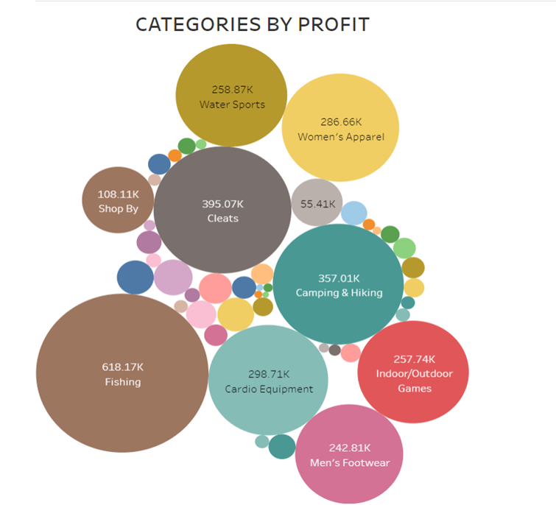

***Figure 2*:** The above chart illustrates the profit generated category-wise

We tried a couple of models like ElasticNet, SVR, and MLPRegressor using a 70%-30% split for model training and testing. However, MLPRegressor performed the best with an RMSE of 84.54. So, we decided to deploy the same for our forecasting.

As MLPRegressor is a neural network, it is a computation model that mimics the structure and function of the human brain. Consisting of connected nodes, or neurons, arranged in layers, neural networks are visionaries at pattern recognition and information processing jobs. The input layer is fed with input data that passes through hidden layers via weighted connections and finally produces an output at the final layer. They contribute to inventory management by optimizing stock levels and minimizing excess or insufficient supplies. The justification for selecting the size of the hidden layer nodes in the neural network model is based on a conventional formula (⅔* input columns + output column), suggesting a range of values from 20 to 72 nodes. The analysis indicates that doubling the node size only marginally reduces the root mean square error (RMSE), and choosing a smaller node size (27) provides similar accuracy with less computational time.

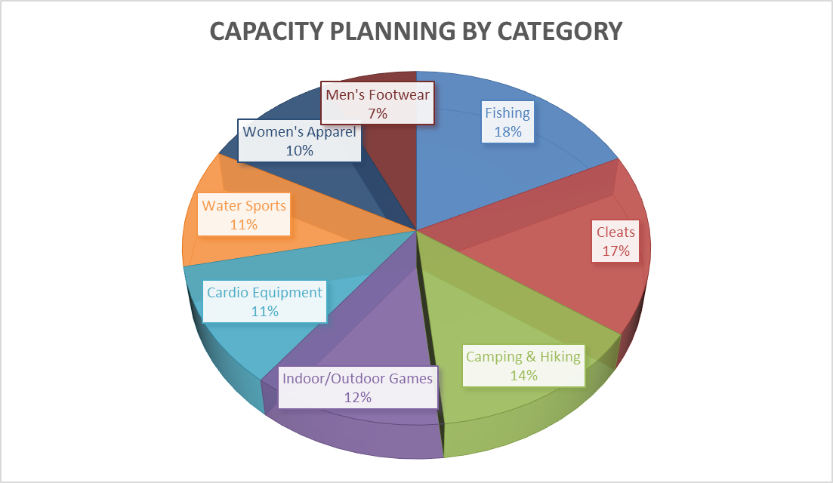

***Figure 3:*** The above pie chart illustrates the Capacity planning category-wise as predicted by ML

By using the pie chart above, VDOMES will be able to focus their resources such as warehouse capacity, inventory-related costs, and shipping costs on most sold items on their platform, thus, increasing their cash flow and reducing their overheads and cost of carrying inventory. The above categories are predicted to be the highest selling on their online platform next year, therefore, the company will minimize potential losses due to unavailable inventory or delayed shipping times leading to order cancellations or order returns on these categories. VDOMES would be able to keep their customers happy and fulfill the orders on the promised delivery date at the time of order.

**Benefits**

Implementing a machine learning predictive model based on Neural Networks can significantly enhance a company's ability to manage sales and inventory, leading to strategic advantages. This model will focus on allocating resources efficiently towards product categories with high predicted volumes. Consequently, it will aid in optimizing warehouse space, cutting inventory-related expenses, and minimizing transportation costs. These improvements are crucial for enhancing cash flow, reducing indirect costs, and lowering inventory expenses.

For instance, analyzing patterns of late deliveries, particularly in categories like "Cleats," this approach enables the company to forecast demand surges and adjust inventory levels proactively. This adjustment will likely lead to a decrease in late shipments. The model's utility is further illustrated by the Profit-by-Category chart, where "Fishing" and "Cleats" emerge as major profit contributors. Accurate sales trend predictions in these sectors enable the company to maintain ideal inventory levels, meeting consumer demands without incurring excess stock, thus conserving capital and storage space.

Enhanced customer satisfaction and retention, coupled with reduced expenses due to delayed shipments, are the direct benefits of this approach. For example, if the model anticipates a surge in the "Women’s Apparel" category sales, the company can increase sourcing beforehand, preventing stock shortages during high-demand periods. These strategies empower the company to manage its sales inventory more effectively and boost shipping efficiency for the upcoming year. This leads to reduced risks of shipment delays, increased customer satisfaction, and a stronger competitive position in the market.

**Challenges**

In today's fast-paced and ever-changing business landscape, traditional inventory management methods are increasingly proving inadequate. Manual forecasting and reorder point calculations, which were formerly the cornerstone of inventory management, are now prone to mistakes and limitations. These methods, while effective in simpler times, struggle to keep pace with the complexities of modern markets, where customer preferences shift rapidly, and supply chains are interconnected on a global scale.

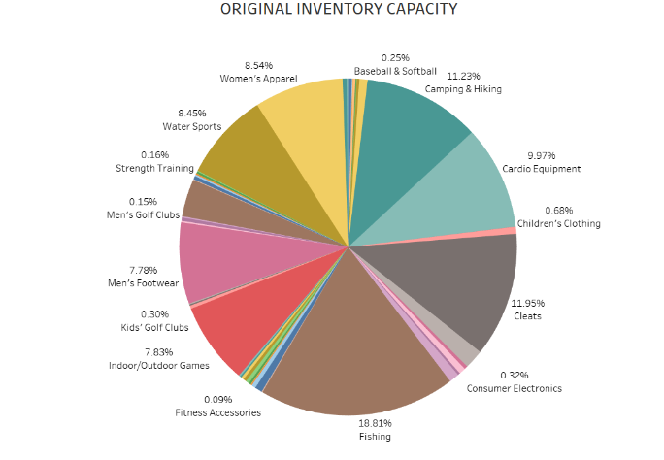

***Figure 4:*** The pie chart illustrates the original inventory capacity for product category.

Manual forecasting and replenishment systems, though once the best available option, now face significant challenges in analyzing the large amounts of data generated by modern business operations. Predicting demand accurately has become increasingly difficult, as historical data alone may not capture the full spectrum of factors influencing consumer behaviour and market dynamics. As a result, we often find ourselves grappling with stockouts, excess inventory, and inefficient allocation of resources.

To overcome these challenges, we are turning to advanced machine-learning techniques for predictive analytics. By harnessing the power of past data and employing sophisticated algorithms, machine learning offers a more accurate and adaptive approach to inventory optimization. These techniques will enable us to anticipate shifts in demand, identify patterns and trends in consumer behaviour, and optimize inventory levels accordingly.

The transition from traditional to advanced inventory management methods is driven by the imperative to stay competitive in today's marketplace. By leveraging machine learning algorithms, we can mitigate the risks of stockouts, minimize excess inventory holding costs, and ensure a more agile and responsive supply chain. Moreover, the insights gained from advanced analytics can inform strategic decision-making, enabling us to allocate resources more effectively and capitalize on emerging opportunities.

In essence, the adoption of advanced machine learning techniques represents a paradigm shift in inventory management. By embracing data-driven approaches, we can adapt to the demands of modern business environments, enhance operational efficiency, and ultimately drive sustainable growth in an increasingly competitive landscape.

Inventory optimization means keeping just the right number of products we need to meet customer demand while minimizing costs. We need to be able to change and adjust our inventory plans to deal with changes in the market or challenges faced by suppliers. Flexibility enables adjustments in inventory levels, reorder quantities, and product offerings, while adaptability facilitates quick assessment of situations, informed decision-making, and implementation of necessary changes to optimize inventory and meet customer needs.

Another challenge is the ever-increasing need to maintain the cash flow by increasing the product categories that are highly profitable in stock while decreasing or completely removing the less profitable categories. Managing cash flow effectively involves continuously finding ways to increase revenue and maintain enough stock of products that are high in sales and profit. This means figuring out which products make the most money and focusing on allocating resources toward their growth while cutting back on less profitable categories. To do this well, we need to keep an eye on sales data, what people are buying, and what's popular in the market. By doing this, we can utilize our resources wisely and make sure we’re making as much profit as possible to maintain our cash flow.

It's also important to understand product profitability, we need to find a balance between selling products that make money and managing our inventory smartly. This means finding ways to utilize products efficiently, not keeping too much stock on hand, and making sure our supply chain runs smoothly. By doing this, we can keep our cash flow strong and our finances in good shape.

In short, managing cash flow well means making smart choices about what products to sell and how to manage inventory. By doing this, we can stay strong even when market conditions change, making sure we’re financially stable in the long run.

**Conclusion & Recommendation**

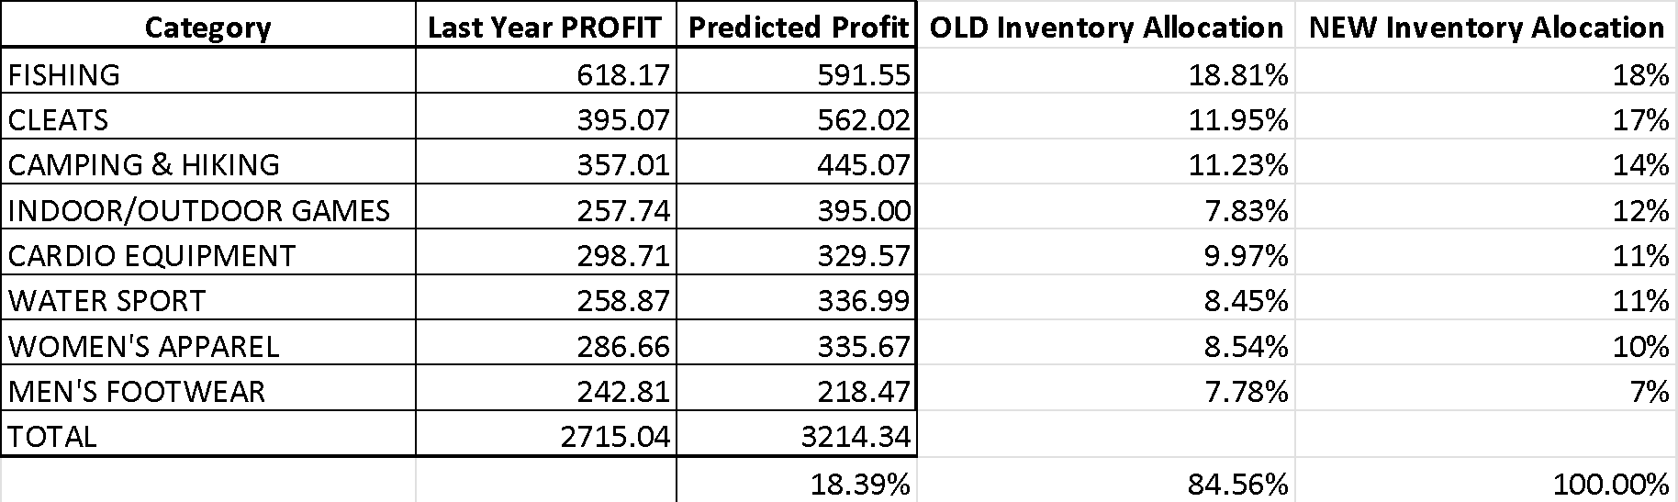

***Figure 5*:** The above table illustrates the new inventory allocations for high-selling categories

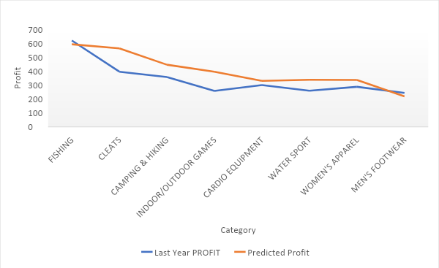

***Figure 6*:** The above graph illustrates the predicted profit based on the new allocations.

In conclusion, the utilization of neural networks into VDOMES' inventory management system addresses the intricate challenges of inventory optimization within a rapidly growing e-commerce landscape. This machine learning approach, particularly through the use of an MLPRegressor, has demonstrated a remarkable ability to predict product backorders, thus ensuring a more strategic allocation of resources towards high-demand product categories. By accurately forecasting sales and adjusting inventory levels accordingly, VDOMES is poised to not only mitigate the issues of late deliveries and stockouts but also to significantly enhance its profitability and customer satisfaction. The targeted focus on optimizing the inventory of the most profitable and popular product categories, as informed by predictive analytics, aligns perfectly with the company's objective to streamline its supply chain operations. This optimization not only promises a reduction in operational costs but also reinforces the company's agility in responding to market demands. Consequently, VDOMES is now better equipped to maintain a competitive edge in the e-commerce domain, thanks to a more responsive and efficient inventory management process powered by the strategic application of neural networks.

**Strategic Focus on High-Selling Categories:** It is recommended that VDOMES narrows its focus to high-selling and profitable categories. This involves not only prioritizing these categories in terms of inventory space and resources but also exploring ways to expand their market reach and customer base.

**Phase Out Low-Performing SKUs**: Concurrently, VDOMES should consider gradually phasing out low-performing Stock Keeping Units (SKUs) that contribute minimally to profitability and occupy valuable inventory space. This decision should be data-driven, based on predictive analytics insights.

By implementing these recommendations, VDOMES can further enhance its inventory optimization efforts, ensuring that it not only meets the current market demands efficiently but also positions itself strategically for future growth and profitability in the competitive e-commerce landscape.

**References**

DataCo SMART SUPPLY CHAIN FOR BIG DATA ANALYSIS. (n.d.). www.kaggle.com.